OUR LOCAL ‘MASTERS’ PLAYERS

Not only is the county’s Masters’ groups thriving, but so is the domestic Masters Tournament circuit. ‘Masters’ start at Over 35 but most tournaments start at Over 40 and several include singles and doubles games. The tournaments are graded from Bronze to Gold, depending on expected ability and organisation.
Players from Hildenborough, AIT, Chelwood Gate, St Johns & Trident currently represent their respective counties and enter these events.
Both Kent and Sussex hold regular Masters’ practise session throughout the summer where anyone can join in. For further information contact myself or either County Masters’ Secretary
The following report shows the positions achieved by our local players.
Masters Tournament Update.
The first (UK) Masters Tournament this season was the
Kent Gold Masters held on 28-30 October in Gillingham.
MS O60 RU Former TWBL & Crowborough resident Martin Staden
MD O60 3rd Martin Staden (prev Trident)
WS O35 RU Mitsuyo Kondo (St John’s)
MD O45 Winners Chris Spice & Kenton Jones (St Johns)
MD O70 3rd William Brown & Richard Fischer (Trident)
WD O45 3rd Mitsuyo Kondo & Helen Milne (St Johns)
MXD O45 RU Kenton Jones & Betty Blair (St Johns)
XD O45 3rd Phil Troke & Mitsuyo Kondo (St Johns)
*TWBL players in bold.

The second Tournament was the
Cumbrian Masters held in Carlisle on 15/16th October.
MD 60 Winners Former TWL player and Crowborough resident Matin Staden & Nigel Fell

MXD 60 Jt 3/4th Martin Staden & Kay Armer

MD 70 4th William Brown & Peter Lonnen (Trident)
*TWBL players in bold.

Northumberland Silver in Newcastle 4 Nov to 6 Nov.
MD O60 3rd Martin Staden & Nigel Fell
MS O60 Winner Martin Staden
MD O70 RU William Brown & Peter Lonnen (Trident)
XD O60 RU Martin Staden & Kay Armer
*TWBL players in bold.

West of England Masters 2022 held in Bath on 19/20 November.

MD O70 3rd William Brown & Richard Fischer (Trident)
MD O70 4th Dave Chapman & Edward Hayes (Hildenborough)
*TWBL players in bold.

English Nationals at Hatfield on 2/3/4th December
^{MS O45 Winner} ^{Kenton Jones} (St Johns)
^{WS O40 4th} ^{Mitsuyo Kondo} (St Johns)
^{WS O50 3rd} ^{Joana Platts-Mills} (St Johns)
^{MD O50 3rd} ^{Steve Baker & Graham Carson} (St Johns)
^{MD O60 4th} ^{Dave Treacher & Mark Walden} ^{(Hildenborough)}
^{MD O70 4th} ^{William Brown & Bob Bell} (Trident)
^{WD O50 4th} Joana Platts-Mills & Gretchen Rowles (St Johns)
^{MXD O45 2nd} ^{Kenton Jones & Betty Blair} (St Johns)
*TWBL players in bold.

There have also been two European Masters events, Spain and Denmark where several of our players took part.
Most recent was the annual Masters’ Inter-Counties Challenge. This is held over a weekend, at five locations around England with 37 counties and regions taking part from England Scotland & Wales. Some counties had second teams in lower divisions, taking the number of 139 teams taking part. Many of our league players were representing their respective county.

The results this year were:

O40’s Div Prem 1st Lancashire RU Bedfordshire
O40’s Div 1A 1st Cambridgeshire RU Leicestershire
O40’s Div 1B 1st Hampshire RU Kent
O40’s Div 2B 1st Cambridgeshire RU Worcestershire

O45’s Prem 1st Yorkshire RU Surrey
O45’s Div 1A 1st Glasgow RU Worcestershire
O45’s Div 1B 1st Sussex RU Hampshire Featured TWBL players

O50’s Prem 1st Hampshire RU Surrey
O50’s Div 1A 1st Cheshire RU Yorkshire
O50’s Div 1B 1st Kent RU Sussex Featured TWBL players in both teams
O50’s Div 2B 1st Bedfordshire RU Suffolk

O55’s Prem 1st Essex RU Surrey
O55’s Div 1A 1st Hertfordshire RU Nottinghamshire
O55’s Div 1B 1st Sussex RU Somerset Featured TWBL players

O60’s Prem 1st Yorkshire RU Essex
O60’s Div 1A 1st Hertfordshire RU Nottinghamshire
O60’s Div 1B 1st Hampshire RU Kent Featured TWBL players

O65’s Prem 1st Surrey RU Lancashire
O65’s Div 1A 1st Yorkshire RU Lancashire
O65’s Div 1B 1st Sussex RU Hampshire

O70’s Prem 1st Kent RU Surrey Featured TWBL players
O70’s Div 1A 1st Leicestershire RU Berkshire
O70’s Div 1B 1st Essex RU Kent

There are still four main tournaments left on the calendar-Middlesex Bronze Masters, Hants Masters, Yorks Gold Masters and the All England Masters

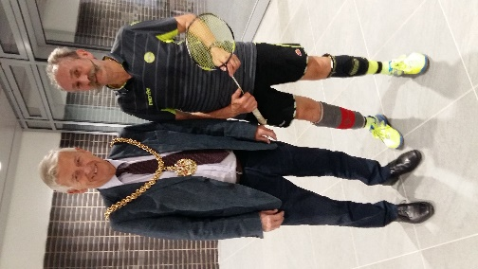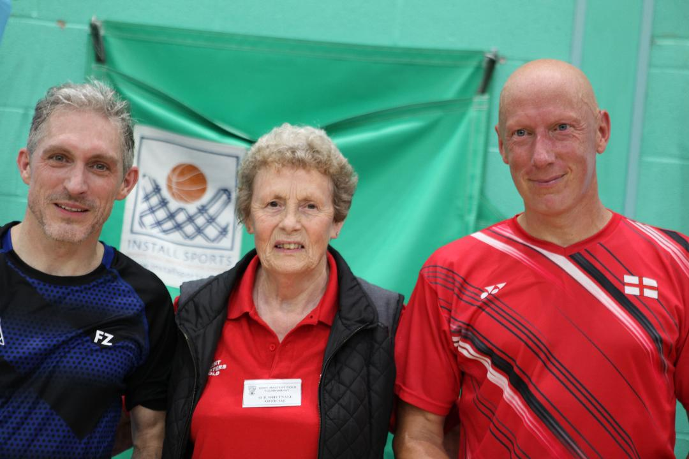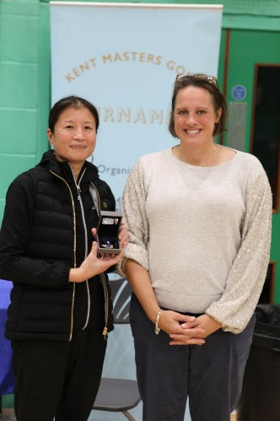

William Brown (Trident) & Mayor of Carlisle Kenton Jones & Chris Spice (St Johns)with Sue Whetnal Mitsuyo Kondo (St Johns)with Heather Crump

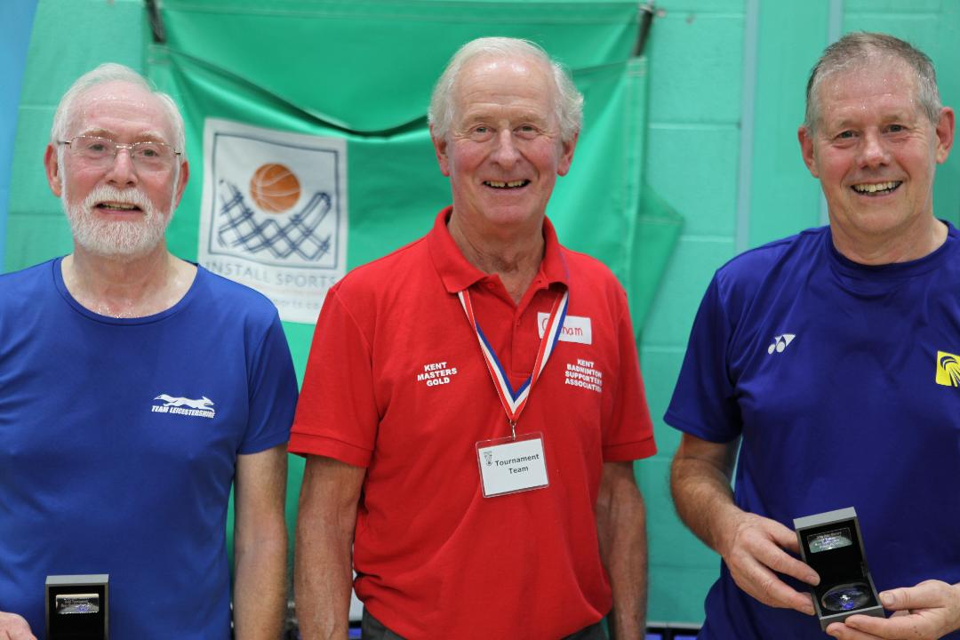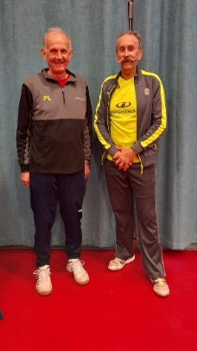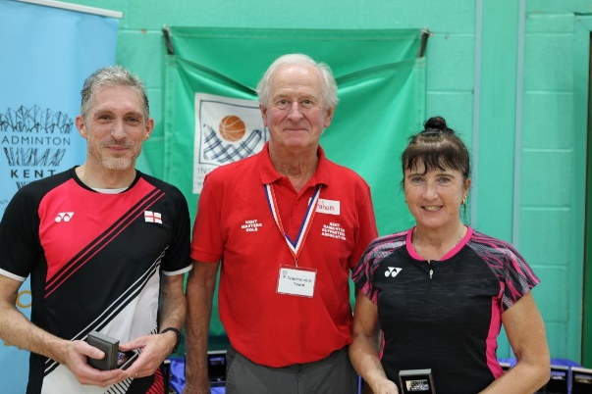

Dave Chapman(Hildenborough)(on R) and Edward Hayes William Brown & Peter Noonen (Trident & Lancashire) Kenton Jones (St Johns) & Betty Blair

Apologies for anyone left out and any spelling errors.
Photos courtesy of John Gardner & William Brown

^{WB}
^{25/01/2023}

